Supplementary materials

Title: A split supply of bio-organic and chemical fertilizer synergistically affects root system architecture and improves above-ground growth in pear tree (Pyrus pyrifolia Nakai)

Journal name: Plant and soil

Authors and addresses: Yalong Kang¹, Xiangrui An¹, Yanwei Ma¹, Yan li², Wenli Wu¹, Caixia Dong¹*, Yangchun Xu¹, Qirong Shen¹

1. Jiangsu Provincial Key Lab for Organic Solid Waste Utilization, National Engineering Research Center for Organic-based Fertilizers, Jiangsu Collaborative Innovation Center for Solid Organic Waster Resource Utilization, Nanjing Agricultural University, Nanjing 210095, China
2. Hubei Key Laboratory of Quality Control of Characteristic Fruits and Vegetables, Hubei Engineering University, Xiaogan 432000, China
* Corresponding authors C. Dong (cxdong@njau.edu.cn)

Supplementary Table S1. Fertilization protocol
Treatment | Chamber | BIO / g | Urea / g  (N 46%) |  | Calcium superphosphate / g  (P₂O₅ 15%) | Potassium chloride / g  (K₂O 50%)
Treatment | Chamber | BIO / g | Base fertilizer | Top dressing | Base fertilizer | Base fertilizer | Top dressing
NF-NF | L | 0 | 0 | 0 | 0 | 0 | 0
NF-NF | R | 0 | 0 | 0 | 0 | 0 | 0
NF-CF | L | 0 | 0 | 0 | 0 | 0 | 0
NF-CF | R | 0 | 17.5 | 8.5 | 45 | 16 | 8
NF-BIO | L | 0 | 0 | 0 | 0 | 0 | 0
NF-BIO | R | 500 | 0 | 0 | 0 | 0 | 0
CF-CF | L | 0 | 17.5 | 8.5 | 45 | 16 | 8
CF-CF | R | 0 | 17.5 | 8.5 | 45 | 16 | 8
BIO-BIO | L | 500 | 0 | 0 | 0 | 0 | 0
BIO-BIO | R | 500 | 0 | 0 | 0 | 0 | 0
BIO-CF | L | 500 | 0 | 0 | 0 | 0 | 0
BIO-CF | R | 0 | 17.5 | 8.5 | 45 | 16 | 8
NF, no fertilizer; CF, chemical fertilizer; BIO, Bio-organic fertilizer. L, left chamber; R, right chamber.
Supplementary Table S2. Properties of the soils from the split-root chambers
Treatments | pH |  |  | SOM  (g kg⁻¹) |  |  | Total N  (g kg⁻¹) |  | NH₄⁺-N  (g kg⁻¹)
Treatments | Left |  | Right | Left |  | Right | Left | Right | Left | Right
NF-NF | 5.46±0.38bc |  | 5.45±0.42bc | 12.53±2.6bc |  | 10.02±1.3c | 1.60±0.4a | 1.65±0.3a | 7.32±1.4d | 6.10±0.7d
NF-CF | 5.36±0.19bc |  | 5.44±0.08bc | 13.49±5.1bc |  | 14.59±0.8b | 1.98±0.3a | 2.11±0.4a | 11.03±0.1c | 14.22±0.3a
NF-BIO | 5.35±0.35bc |  | 5.74±0.13ab | 14.93±1.1b |  | 19.93±6.1a | 1.99±0.4a | 1.82±0.6a | 11.84±0.6bc | 16.01±3.0a
CF-CF | 5.24±0.27c |  | 5.32±0.51bc | 15.63±2.1b |  | 14.75±1.3b | 1.73±0.4a | 1.93±0.5a | 8.03±2.7d | 10.11±0.8cd
BIO-BIO | 6.13±0.31a |  | 6.14±0.10a | 17.13±1.1ab |  | 20.22±1.5a | 2.10±0.4a | 2.16±0.5a | 13.02±1.2bc | 11.88±1.4bc
BIO-CF | 6.16±0.45a |  | 5.45±0.39bc | 20.60±1.6a |  | 13.36±1.7bc | 1.76±0.5a | 2.32±0.6a | 13.32±1.7b | 7.90±1.0d
Treatments | NO₃⁻-N  (g kg⁻¹) |  |  | Available P  (mg kg⁻¹) |  |  | Available K  (mg kg⁻¹) |  | C/N
Treatments | Left | Right |  | Left | Right |  | Left | Right | Left | Right
NF-NF | 4.76±0.7c | 5.05±1.1c |  | 24.38±7.3d | 34.60±8.4d |  | 116.76±19.57c | 146.19±28.62c | 4.80±1.7ab | 3.59±0.6b
NF-CF | 5.41±1.5c | 5.50±0.4c |  | 36.29±5.5d | 57.01±8.6cd |  | 131.81±25.12c | 316.28±98.68a | 3.91±1.2ab | 4.11±0.9ab
NF-BIO | 6.90±2.3bc | 6.77±0.8bc |  | 39.38±4.5cd | 58.80±14.7c |  | 162.22±2.28bc | 216.64±47.17b | 5.04±1.5ab | 5.82±1.3ab
CF-CF | 5.95±2.7c | 10.81±5.8ab |  | 143.57±9.3a | 144.22±30.4a |  | 285.3±18.43a | 319.52±37.31a | 5.38±1.1ab | 4.74±1.6ab
BIO-BIO | 13.44±1.1a | 12.05±0.2ab |  | 81.58±18.3bc | 96.87±14.9b |  | 288.12±56.33a | 316.93±43.51a | 4.84±1.1ab | 5.59±1.1ab
BIO-CF | 10.31±3.6b | 7.15±2.6bc |  | 98.84±24.3b | 71.74±25.95c |  | 280.73±10.44a | 207.73±32.92bc | 7.39±2.9a | 3.48±0.8b
NF: no fertilizer, CF: chemical fertilizer, BIO: bio-organic fertilizer. SOM, soil organic matter; Total N, total nitrogen; NH₄⁺-N, ammonium nitrogen; NO₃⁻-N, nitrate nitrogen; Available P, available phosphorus; Available K, available potassium; C/N, ration of soil carbon content to nitrogen content. Each value represents the mean (n = 3) and standard deviation values are indicated with ±. Different letters indicate significant difference (P < 0.05) in every chamber among the six treatments as determined by Fisher’s least significant difference test (LSD) at α = 0.05.

Supplementary Figure S1. Effects of different fertilizers on yield and SSC of pear. CF, chemical fertilizer; BIO, bio-organic fertilizer. Different lower case letters within the clusters of bars indicate signifcant differences (P < 0.05) according to Fisher’s LSD test.
Supplementary Figure S2. Planting box details. (A) Black plastic base plate. (B) Slidable hollow poles. (C) Assembly of A and B. (D) Black mesh water-repellent plastic side panel. (E) Side view of planting box. (F) Top view of the planting box.

Supplementary Figure S3. Differences in lateral root number based on fertilizer composition (A) 2nd lateral root number, (B) 3rd lateral root number, (C) 4th lateral root number, (D) 5th lateral root number and (E) 6th lateral root number. Error bars represent 1SE of the mean (n = 9). † means significant differences among the CF-CF, BIO-BIO, and BIO-CF treatments using Fisher’s least significant difference test (LSD) at α = 0.05. §means significant differences among all chambers from the six fertilizer conditions using Fisher’s least significant difference test (LSD) at α = 0.05. * means significant differences between the left and right chambers of boxes containing homogenous media using Fisher’s least significant difference test (LSD) at α = 0.05.
Supplementary Figure S4. Differences in lateral root lengths based on fertilizer composition. (A) 2nd lateral root length, (B) 3rd lateral root length, (C) 4th lateral root length, (D) 5th lateral root length and (E) 6th lateral root length. Error bars represent 1SE of the mean (n = 9). † means significant differences among the CF-CF, BIO-BIO, and BIO-CF treatments, using Fisher’s least significant difference test (LSD) at α = 0.05. § means significant differences among all chambers from the six fertilizer combinations using Fisher’s least significant difference test (LSD) at α = 0.05. * means significant differences between the left and right chambers of boxes containing homogenous media using Fisher’s least significant difference test (LSD) at α = 0.05.
Supplementary Figure S5. Anatomy of pear roots. Co: cork layer, ph: phloem, xl: xylem, ve: vessel.
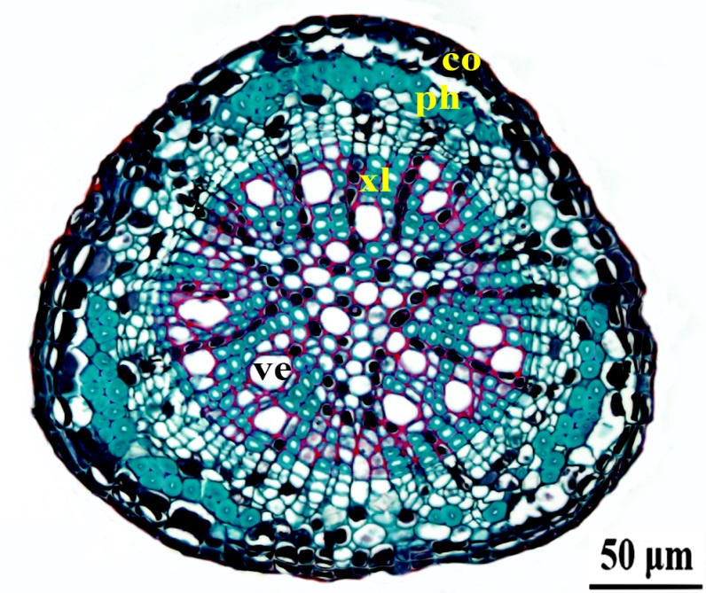

Supplementary Figure S6. Confocal microscopy of GFP-tagged Bacillus amyloliquefaciens SQR9 colonization on pear roots. The green fluorescent protein (GFP)-marked shuttle vector pHAPII (Cao et al. 2011) was electroporated into strain SQR9. The GFP-labeled B. amyloliquefaciens strains were selected against bleomycin and checked using a fluorescence microscope (Zeiss LSM 700, Carl Zeiss, Jena, Germany). Laser scanning confocal microscope (LSCM) images of pear roots colonized by tested strains were photographed with a Zeiss LSM 700 confocal microscope (Carl Zeiss, Jena, Germany) equipped with an EC Plan-Neofluar 20 ×/0.50 M27 objective. Excitation of the samples was performed at 488 nm for chimeric proteins fused to GFP. Fluorescent GFP emission was collected using a combination of filters (SP 555) and a beam splitter (549 nm). Images were assisted with ZEN software (Carl Zeiss, Jena, Germany). (A) root tip, (B) enlargement of the apical colonization site from A, (C) root segment (D) enlargement of the root segment colonization site from B.

References
Cao Y, Zhang Z, Ling N, Yuan Y, Zheng X, Shen B, Shen Q (2011) Bacillus subtilis SQR 9 can control Fusarium wilt in cucumber by colonizing plant roots. Biol Fertil Soils 47: 495-506.

